**Web Programming Project Documentation**

Kevin Angkajaya - 2001589623

Lidya Dameycelina Rias - 2001583065

Yudi Tri Aji - 2001562590

**Table of Reference**

Contents

Exist in all pages: 2

Page for guest 2

Page for Member 7

Page for Admin 9

Hidden Creativities 19

References 23

Exist in all pages:  
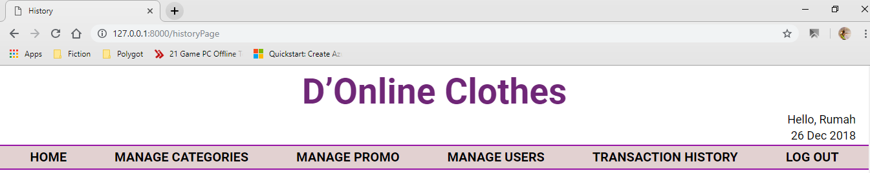  
  
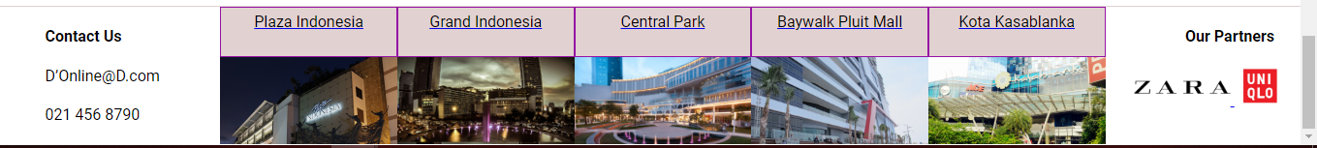  
All pages show navigation, hello message, date, and footer. Each page is managed by middleware (to prevent unauthorized access), for example login page is not accessible after login, while transaction history is only accessible to admins.

# Page for guest

1. Home Page

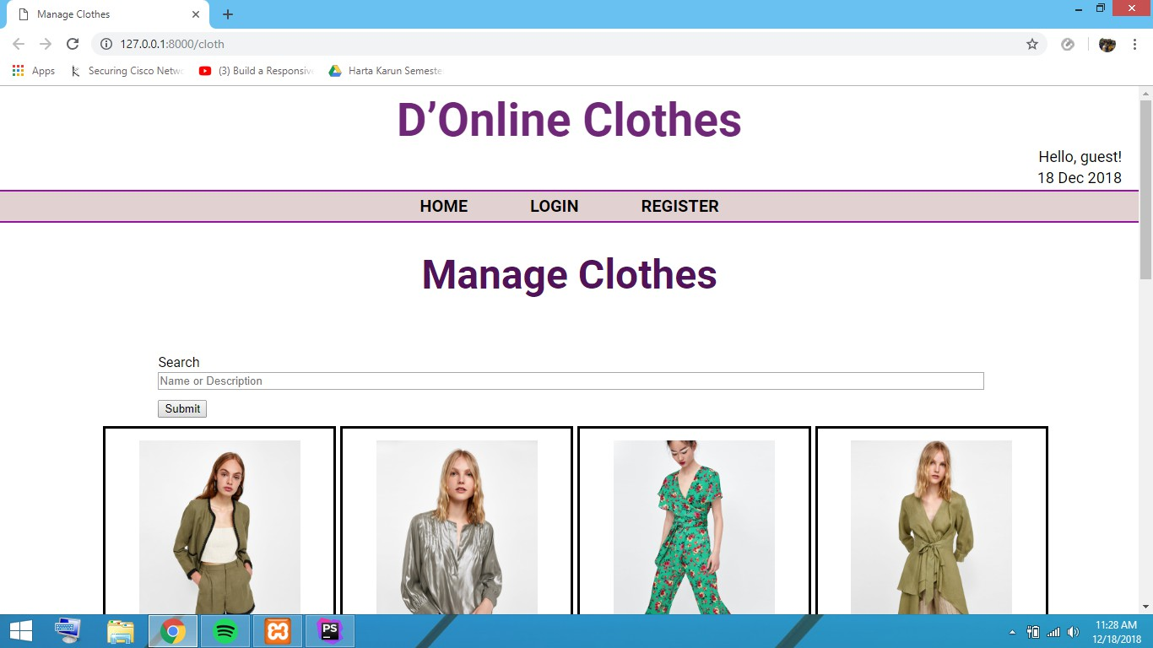

Show all user function and show clothes that are available. Clothes are divided into 8 x 8 grid each page.

Feature shown : Search, Login, Register, Products Display

1. Menu Search

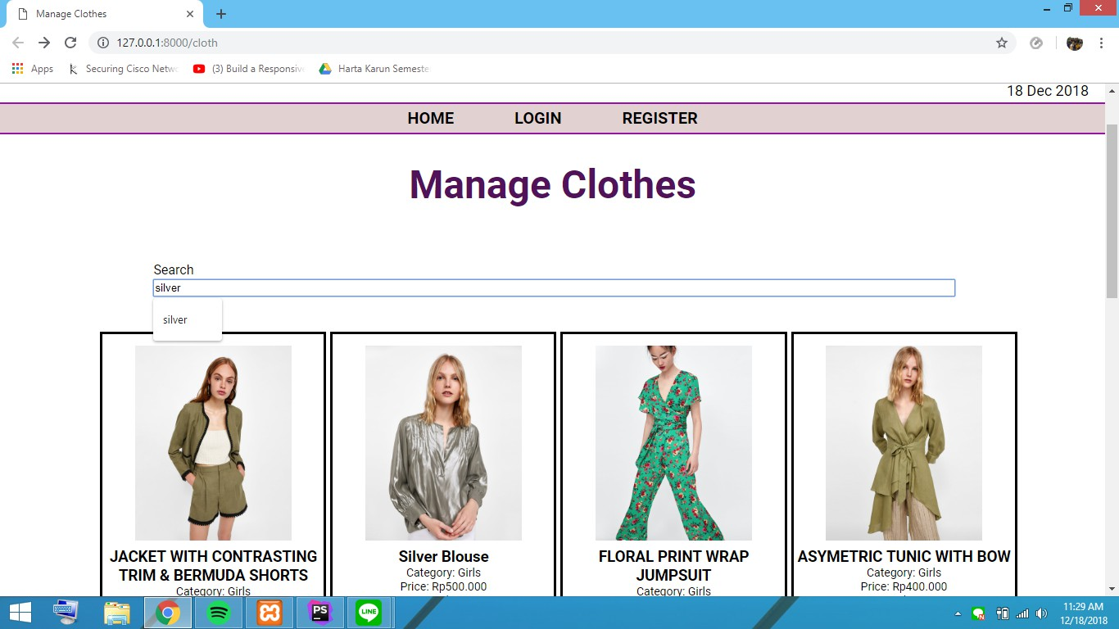

Type a keyword you want to search for product , for example we want to search with ‘silver’ keyword. The result is like this:

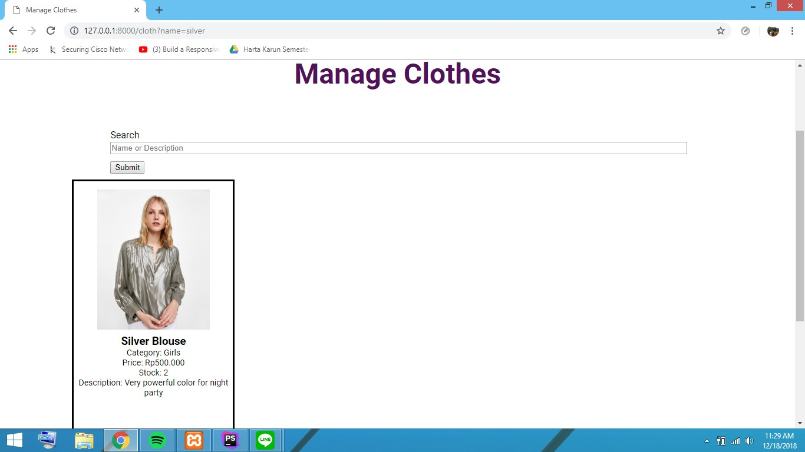

1. Register User Menu

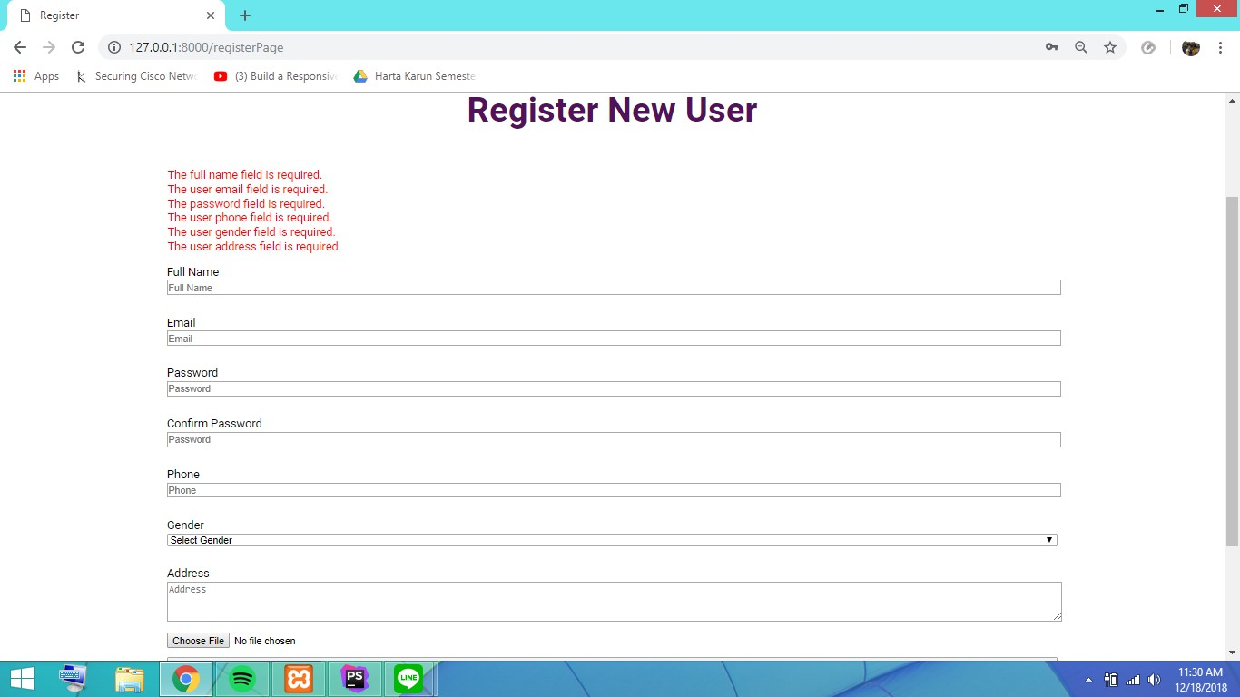

If user wants to be a member , user must fill the register form on Register Menu.

Validates :

* Name must be filled
* Email must be with ‘@’ and ‘.com’ and must be unique.

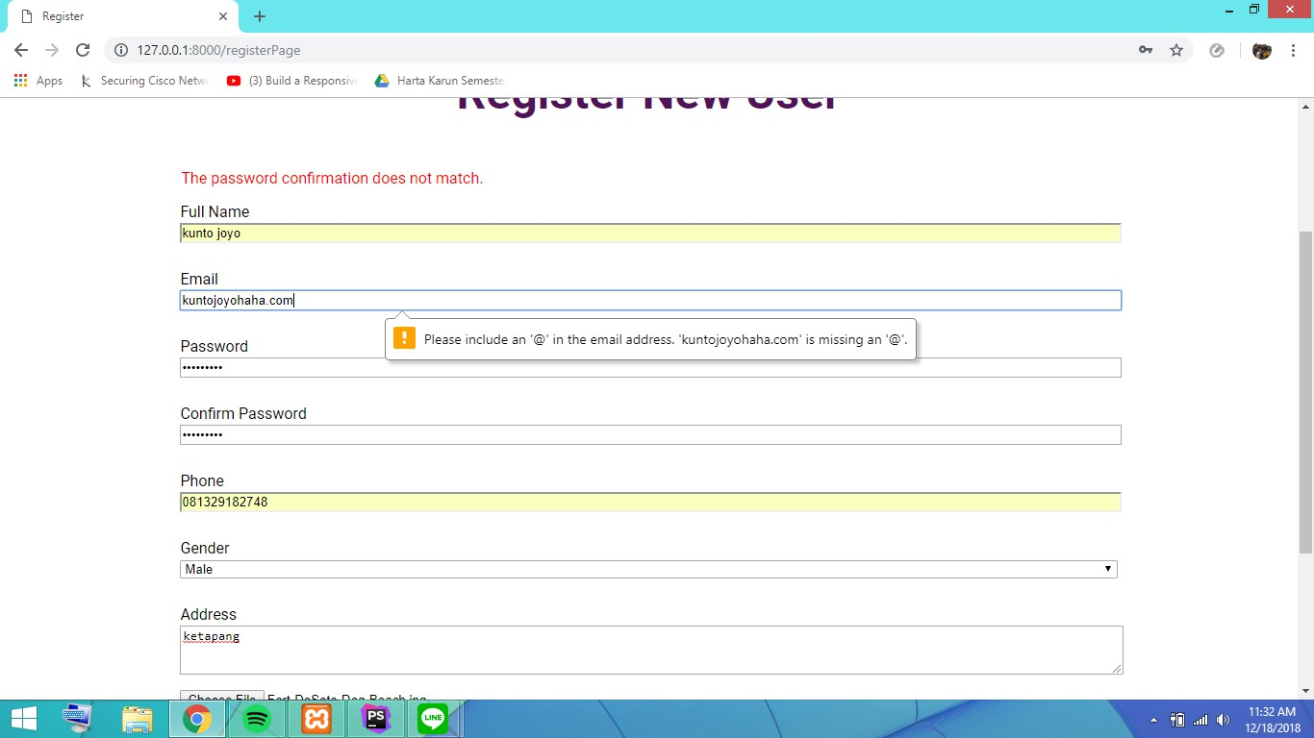

* The password must contain dash and alphabet, should be minimum of 5 characters, the confirmation password must be match with the password
* Phone number is only valid with Number (must be 11 and 12 length)

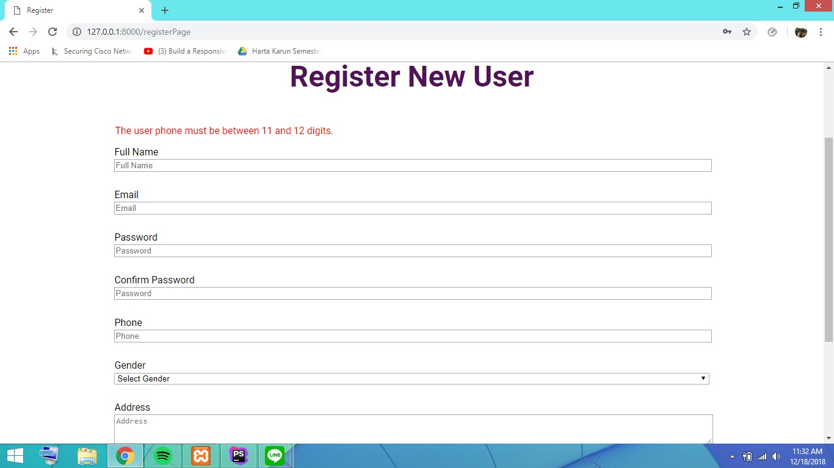

* Address must be filled and must be contain ‘street’ word

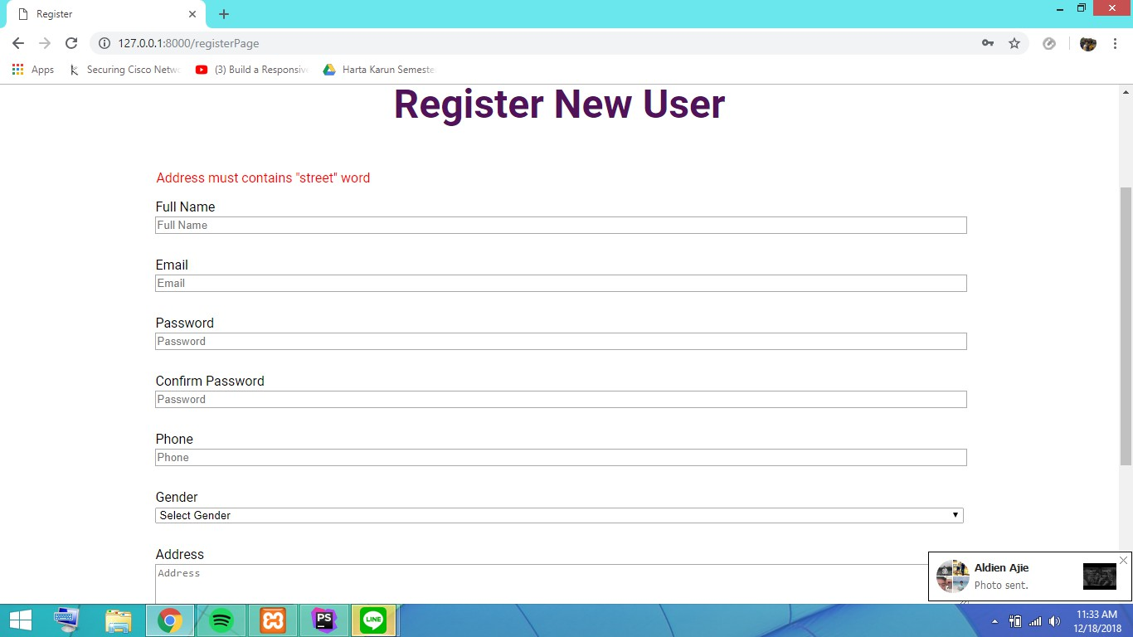

1. Login

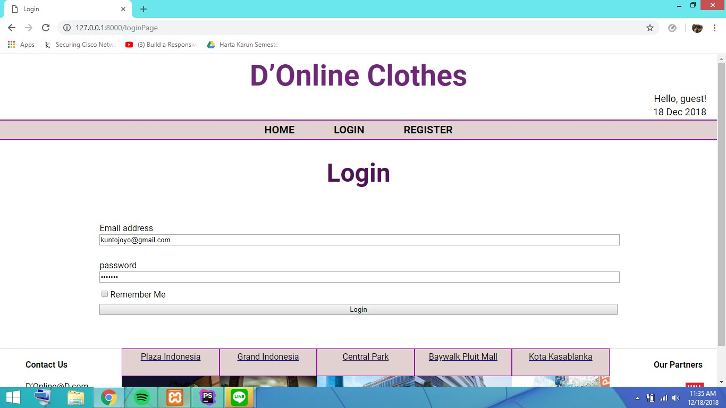

* Fill the email and password box with the information like you have been registered at register form.
* Remember me is used for saving your email and password in browser next time you go to login page. The information is saved for one hour.

# Page for Member

The member page section shows every activity a user can do.

Feature : Home, Cart, Profile, Log Out, Update Profile.

1. Home for Member

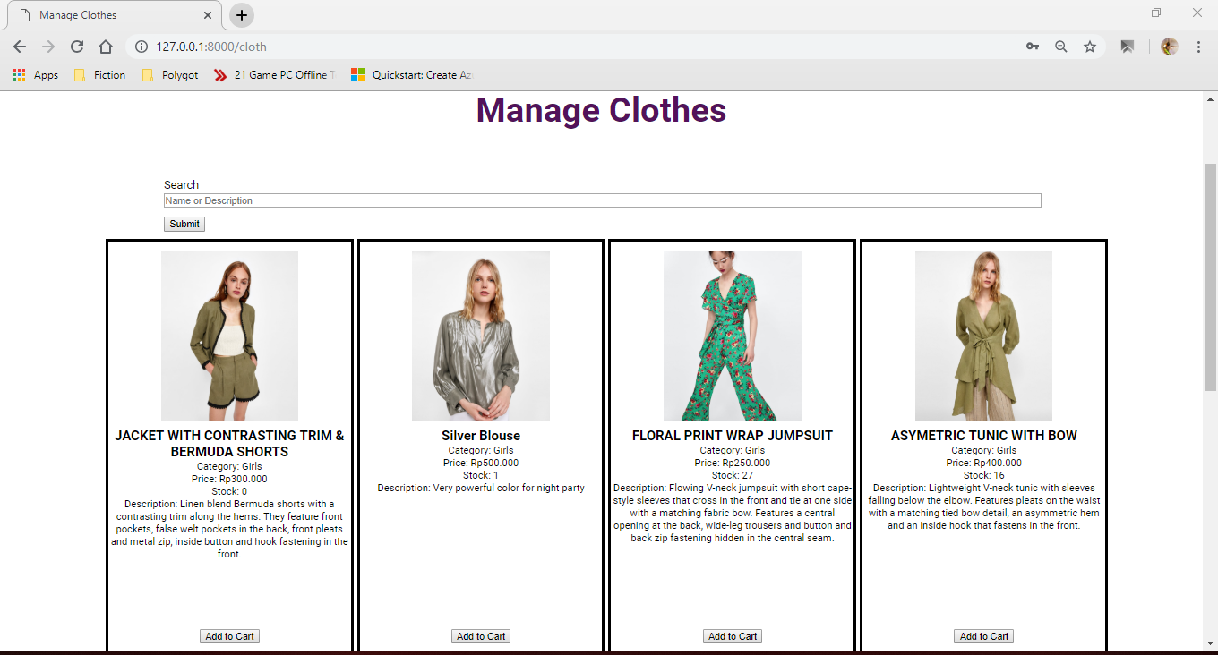

Homepage after login. User can search clothes and add to cart the cloth they wanted. Clothes are divided into 8 x 8 grid each page.

1. Profile Page  
   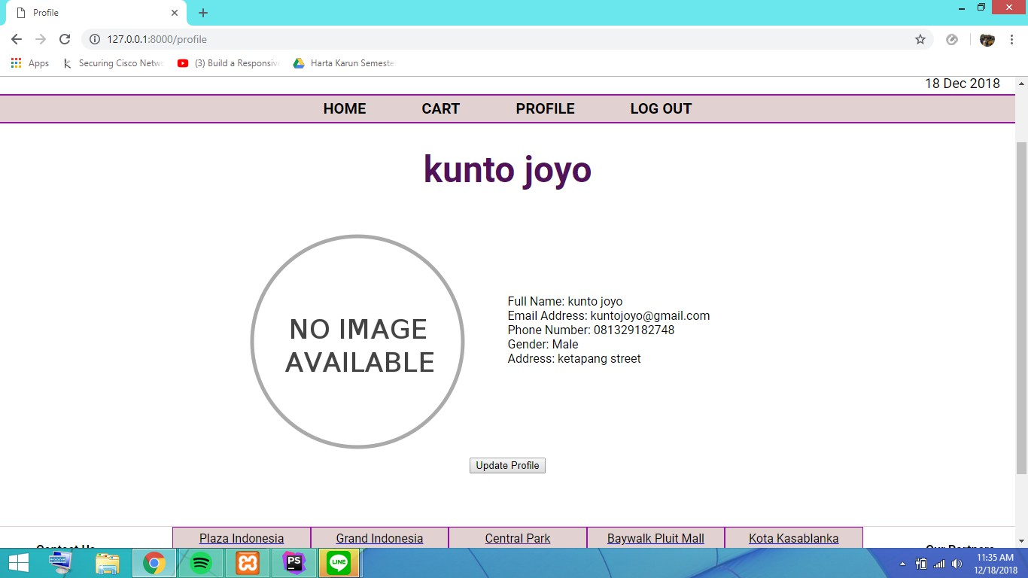  
   The above picture is profile page that shows user’s information and update profile button.
2. Update Profile  
     
   The update profile page is filled automatically with user current details.

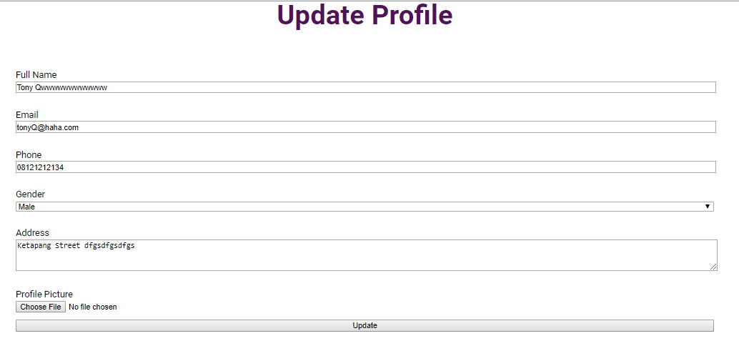

User can add profile picture , edit their name, email, phone, gender and address with the same validation/requirements as in register page. User can also add/edit their profile picture, although it is not required.

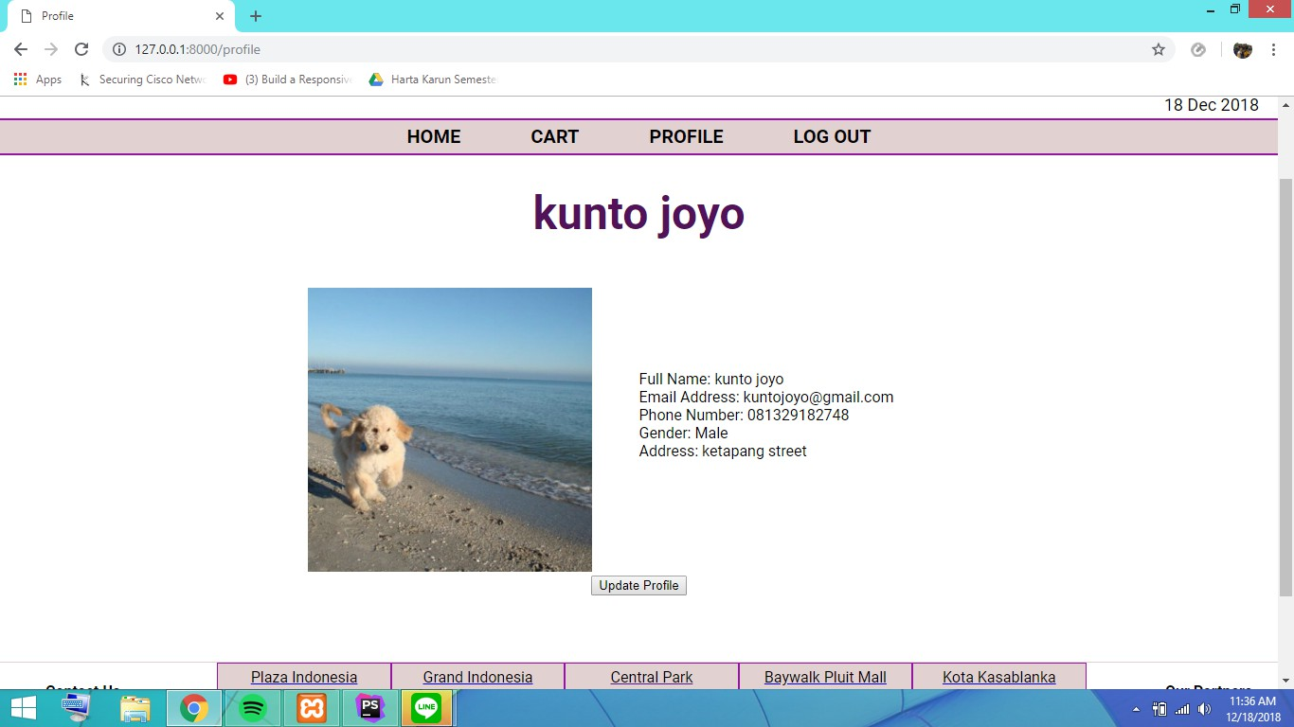

1. Cart

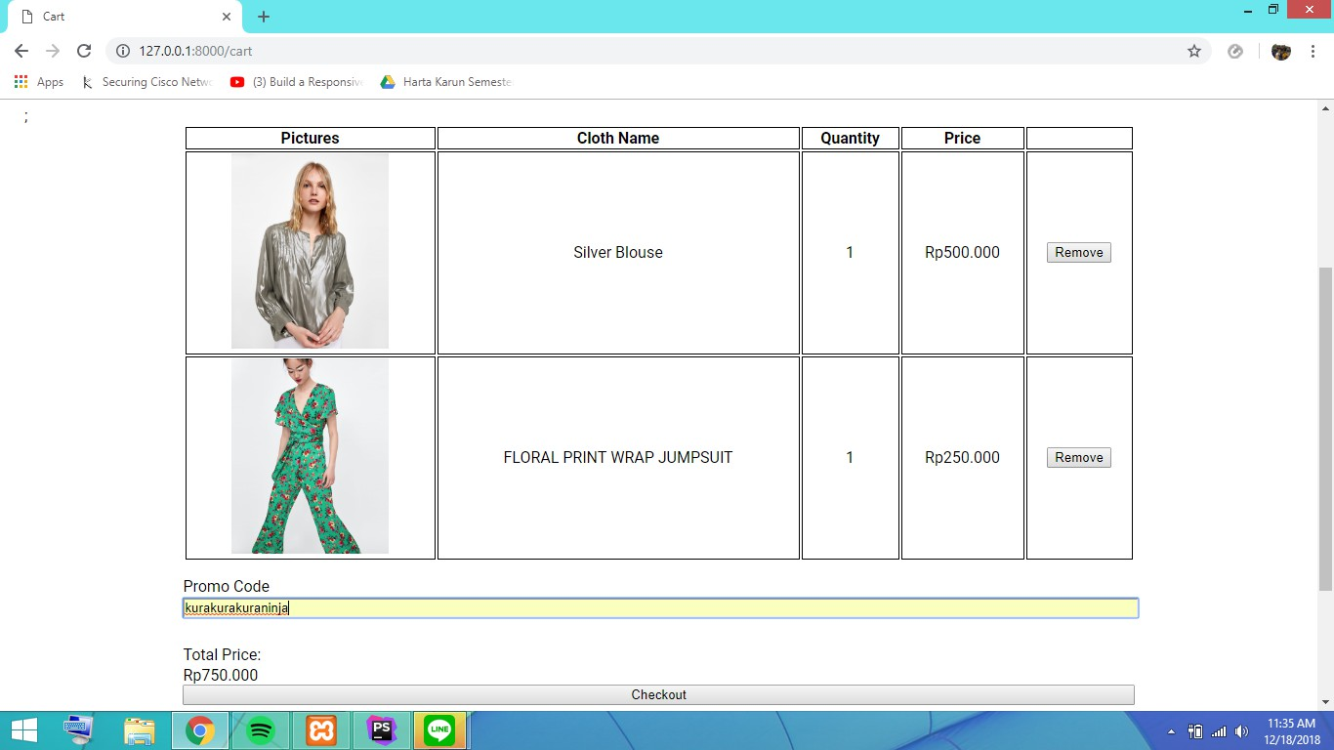

Cart shows all clothes added to cart by user. User may or may not insert promo code to checkout their cart, and if promo code exists user would get discount, else it would show error.

# Page for Admin

1. Manage Clothes  
     
   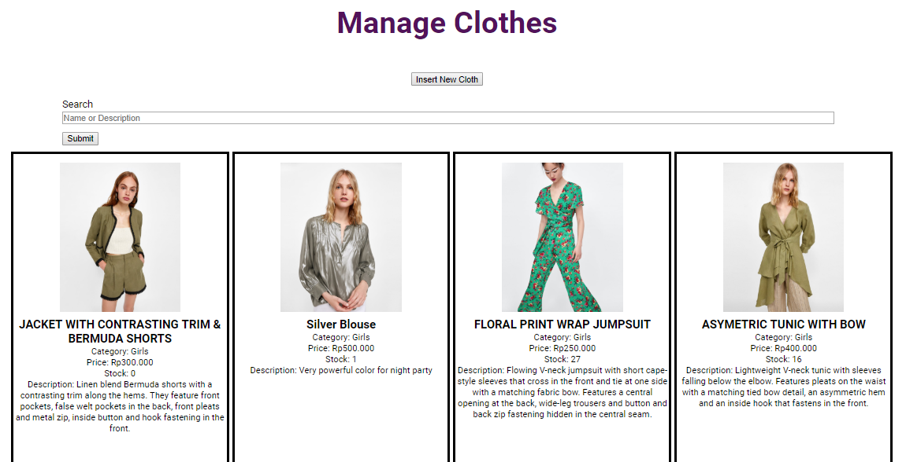  
   Admin can manage clothes, which can insert, update or delete the clothes. Admin can also search in searchbox. Clothes are divided into 8 x 8 grid each page.  
   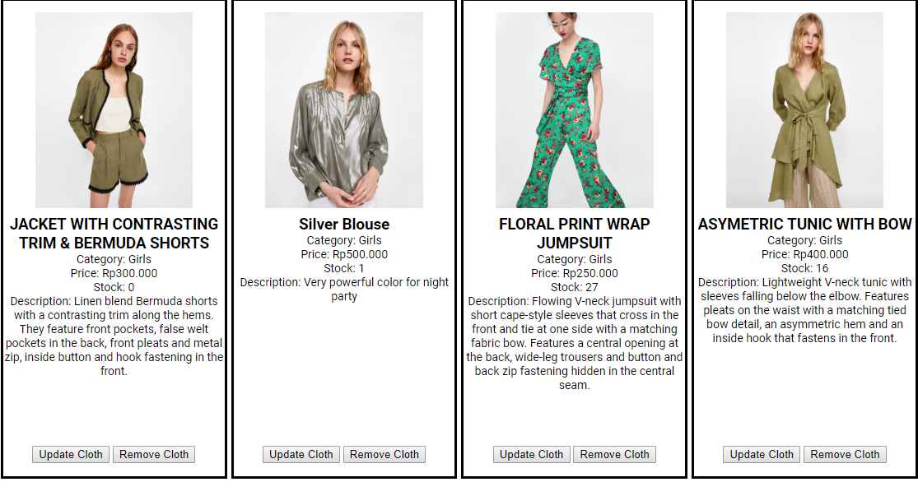  
   Each box contains the cloth information and two buttons, one for update and one for delete.
2. Admin-Insert Cloth  
     
   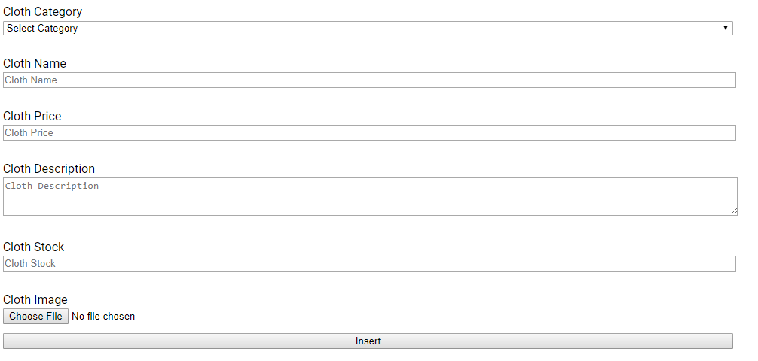  
   Admin can insert cloth and all fields must be filled.
   * Price must be >= 10000
   * Stock must be >= 1
   * Image must be images type (png/jpg) and max size is 5 MB

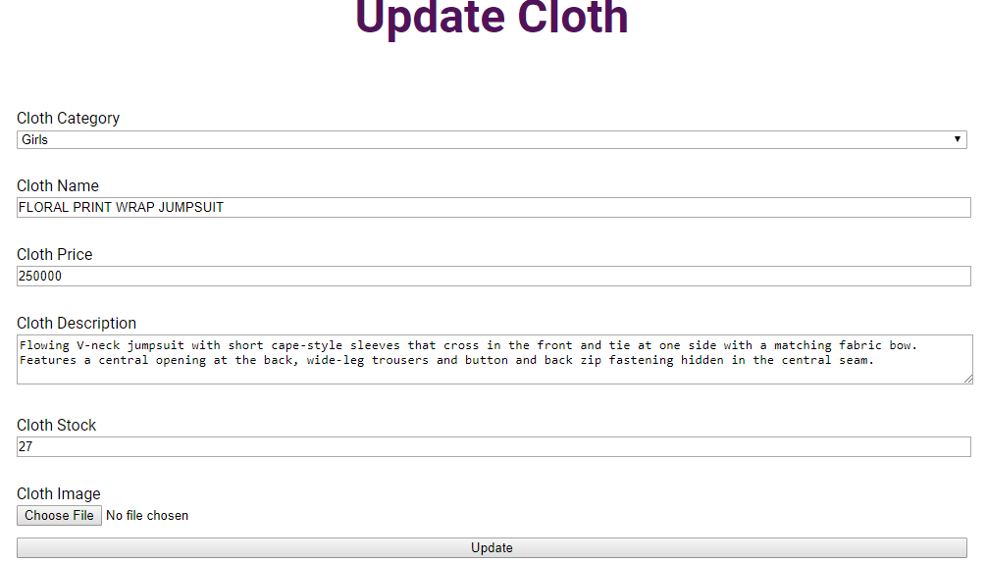  
For updating cloth, validation are the same with inserting. The fields are already filled beforehand with previous information.

1. Admin – Insert Category

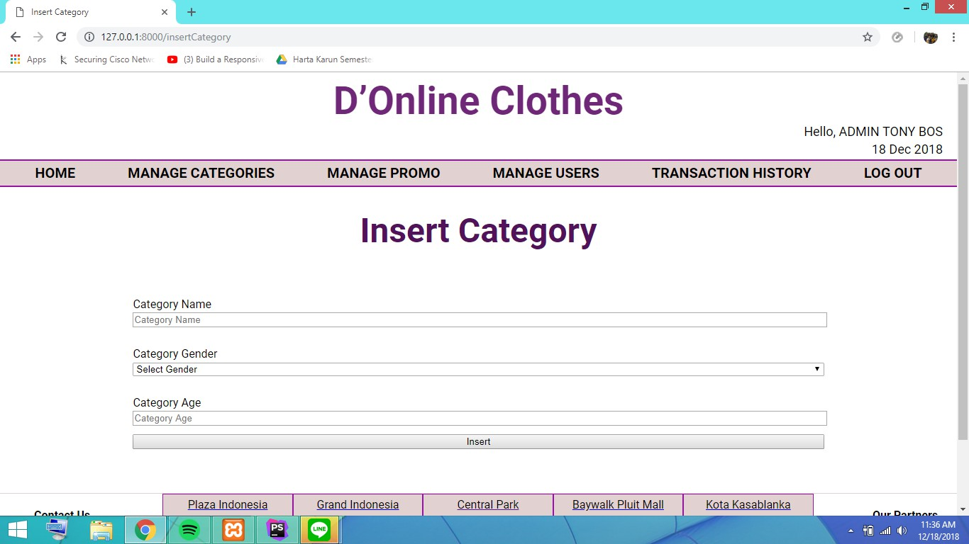

Admin can insert new category here. All columns are required. Age must be more than 0 (zero).

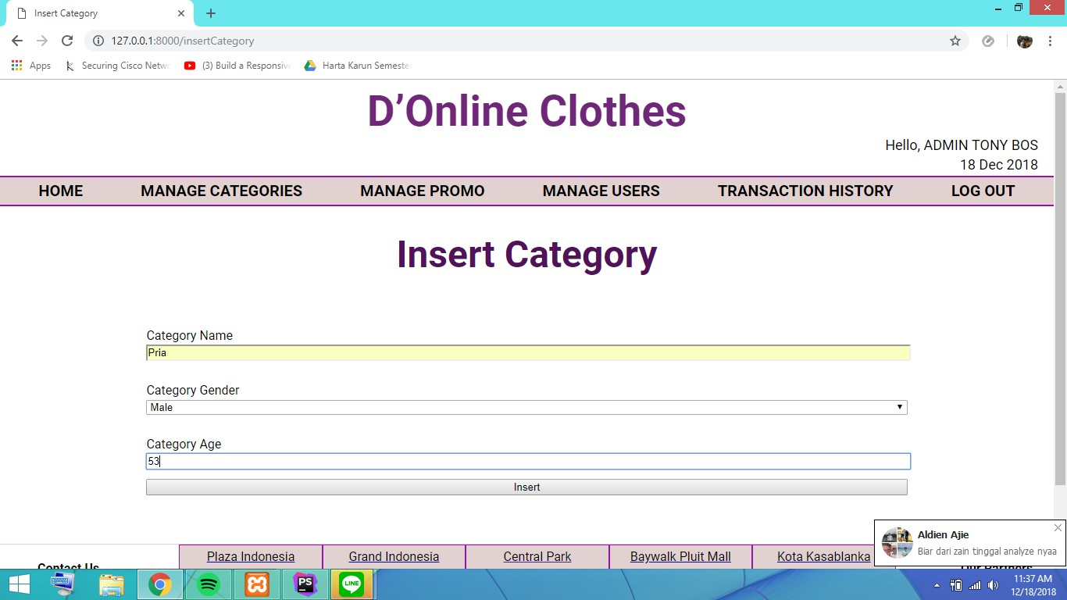

1. Admin – Manage Categories

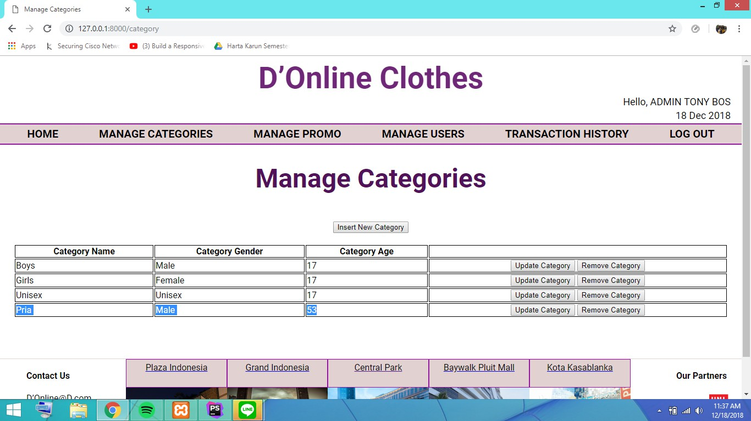

Admin can insert, update and remove category from the website , for example the highlighted part is going to be removed.

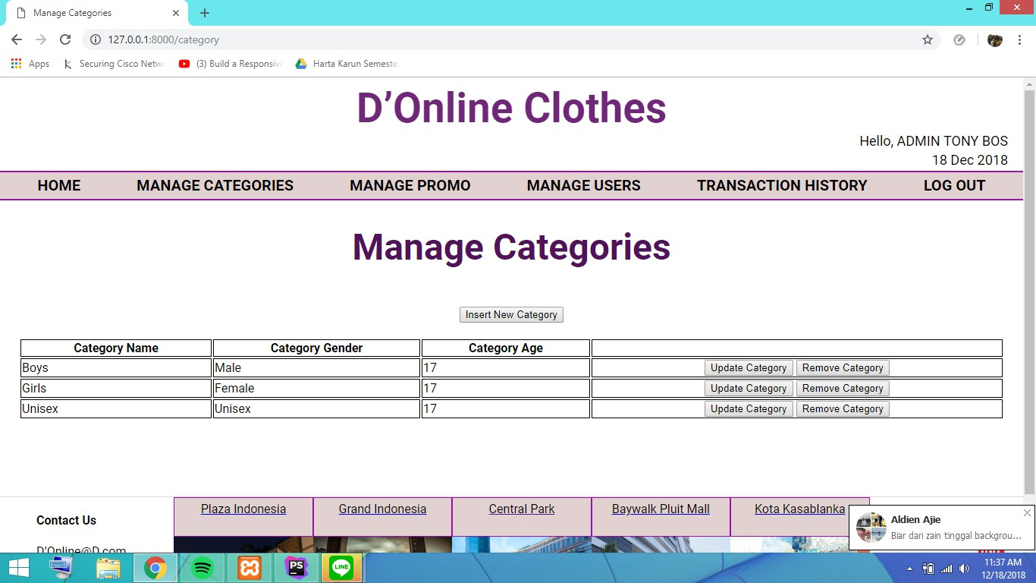

Updating categories page, the textbox is filled automatically with current settings.  
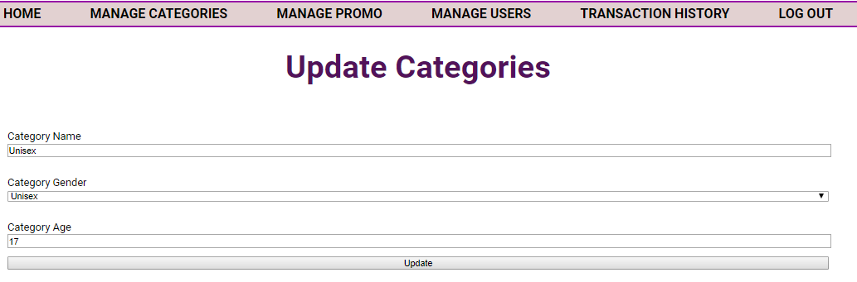

1. Admin - Promo

Admin can add new promo, update and remove promo from the website

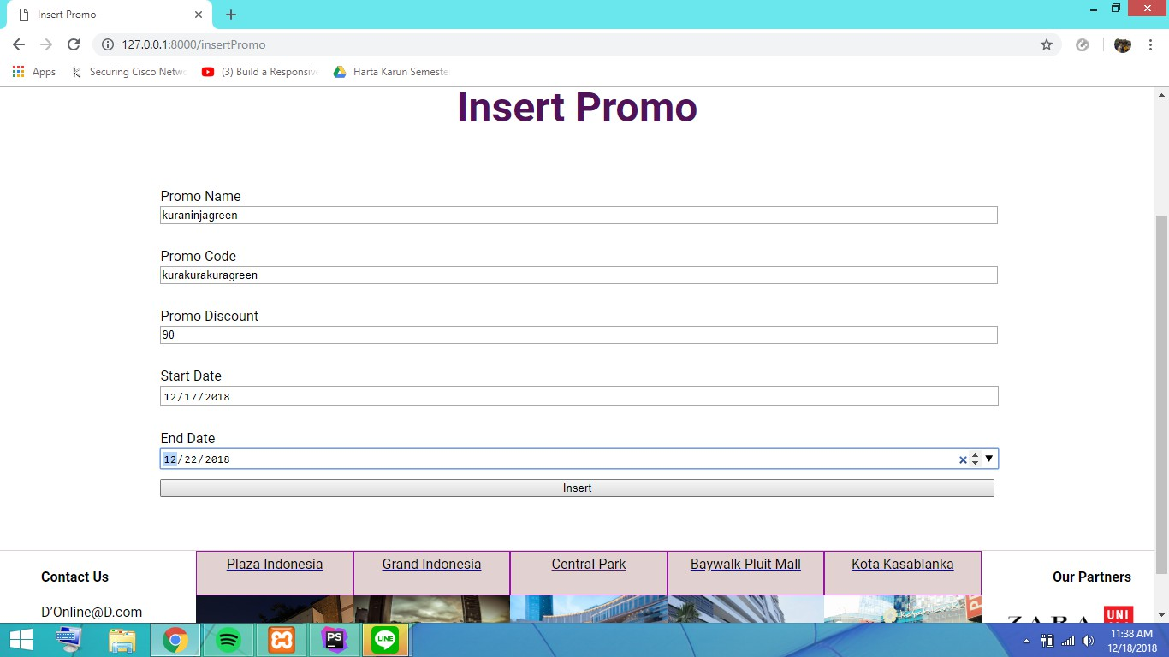

If admin want to add new promo admin must filled all the information are required and set the start date and end date. The code must be in alphabet or dash and between 10 to 30 characters length. Discount is validated between number 1 to 99.

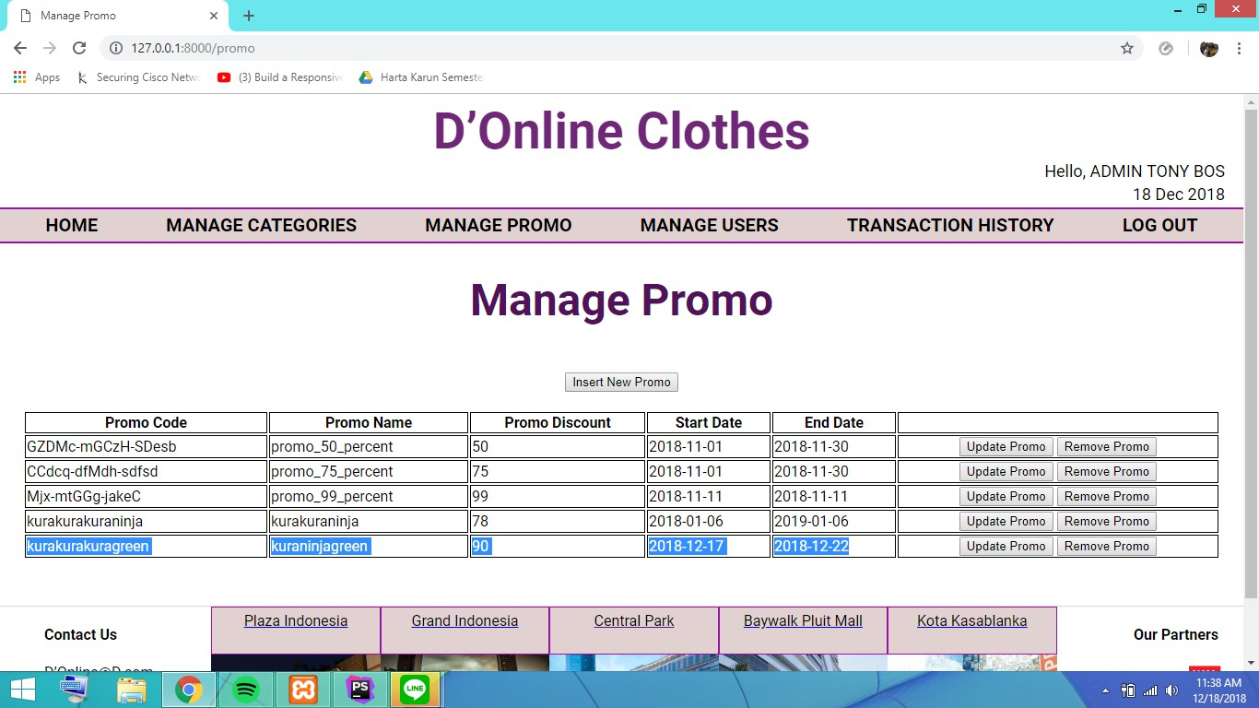

Admin can also remove the promo, for example the highlighted is going to be removed.

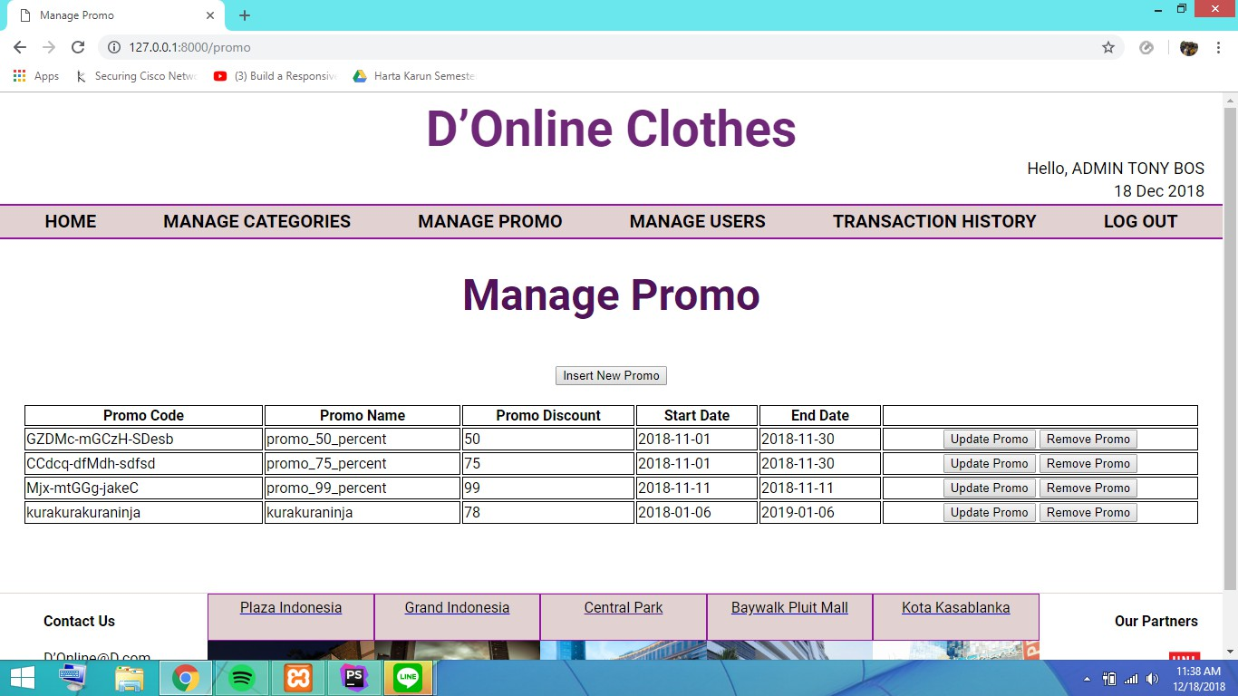

Updating promo page, the textbox is filled automatically with current settings.  
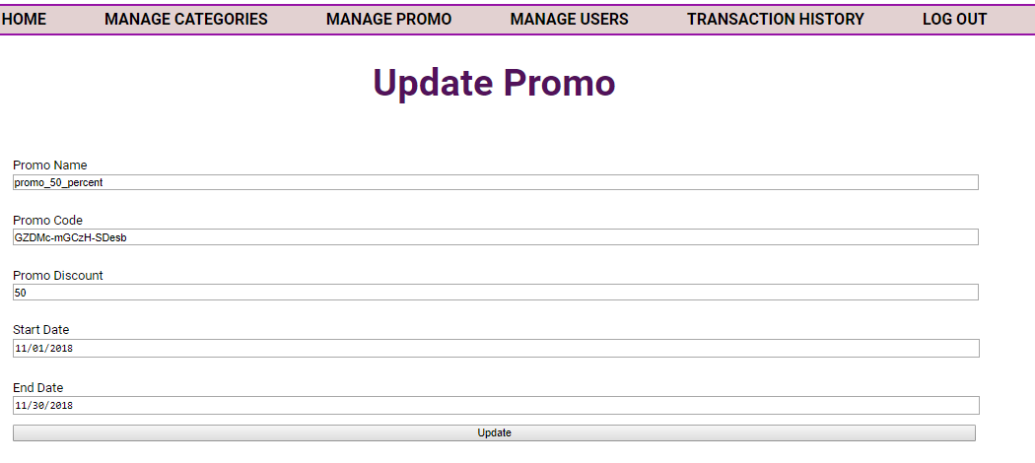

1. Admin – Manage User

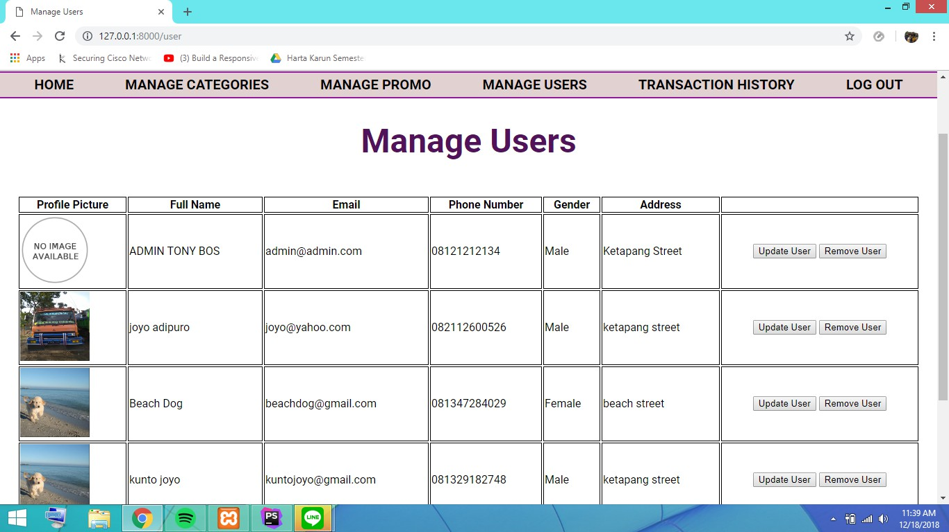

Admin can update and remove user(s).

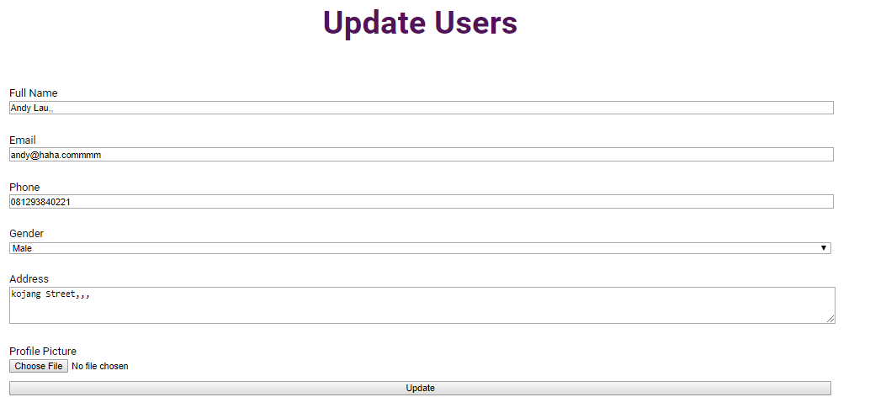

If admin wants to update user, admin must fill all the required columns except for profile picture.   
Phone number must be numbers and between 11 and 12 characters length, and address must contain the word ‘street’

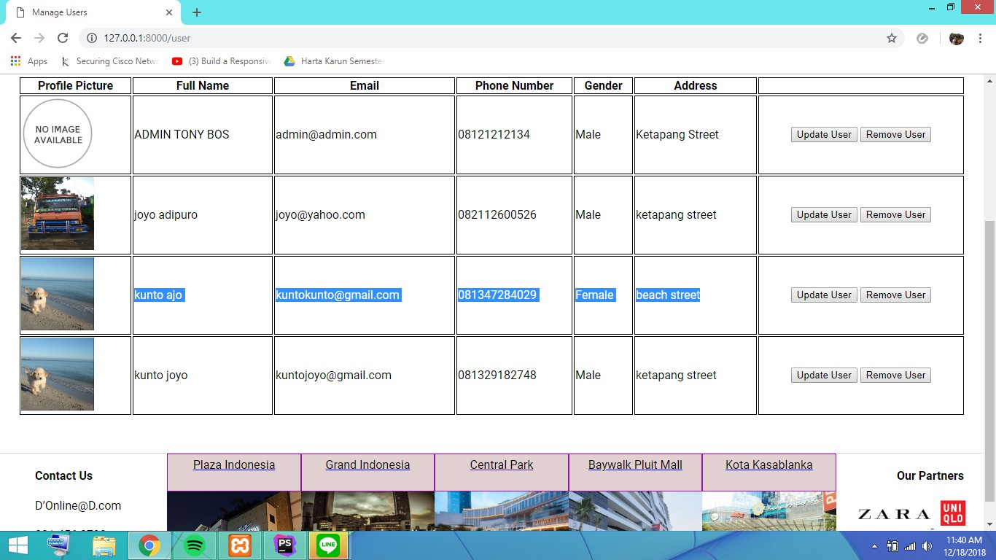

1. Admin - Transaction History  
   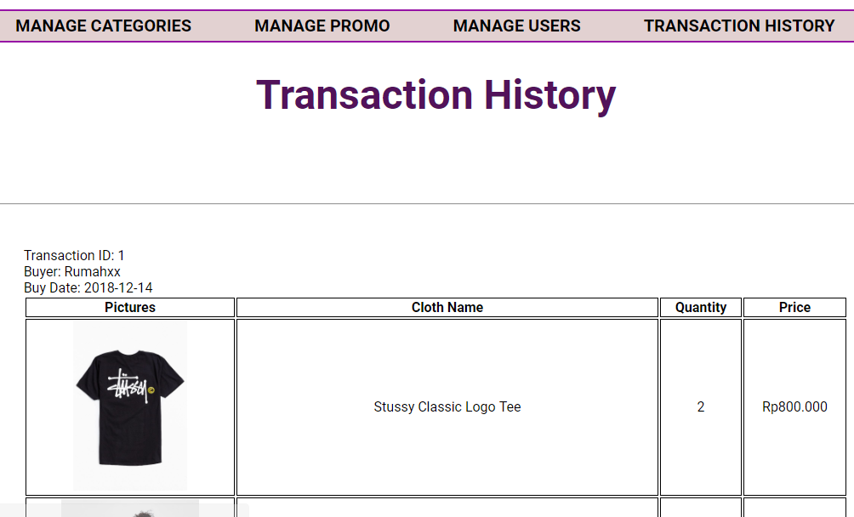  
   Shows all transaction history checkout by users.  
     
   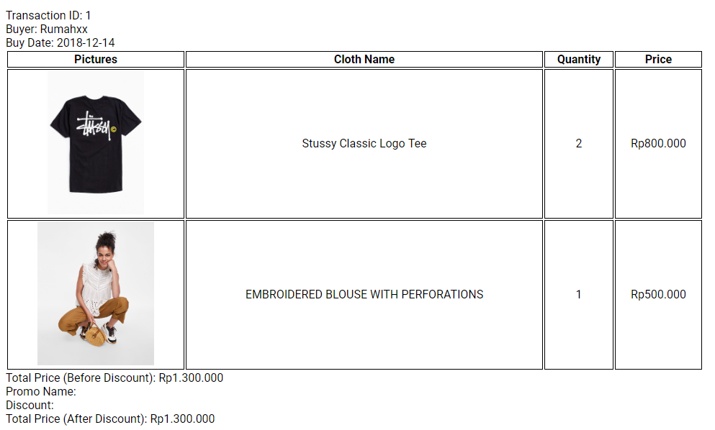  
   Shows all clothes purchased with the promo name and discounted price if exist.  
     
   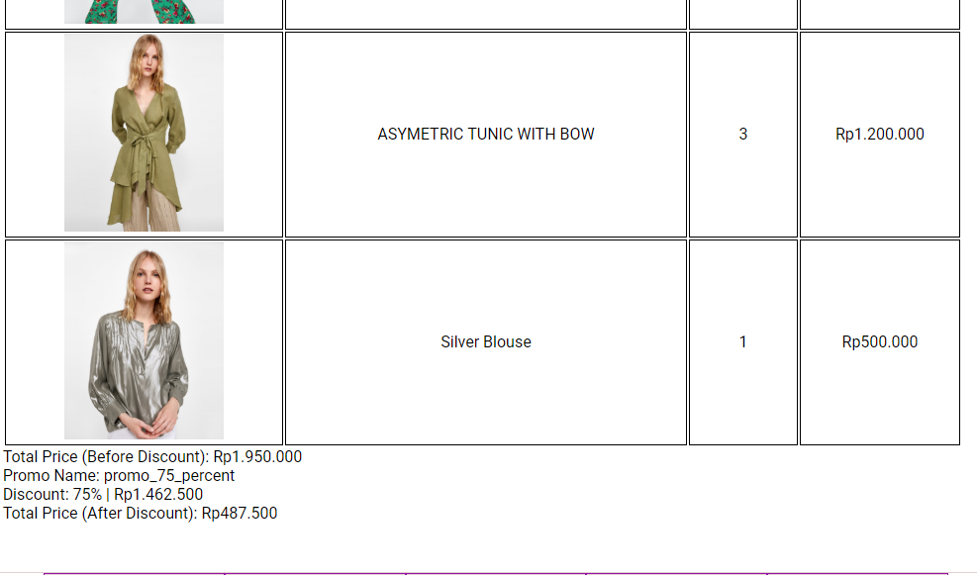

# Hidden Creativities

1. Using ID header == ID header on transaction detail on foreach inside foreach so only relevant clothes appear (in view transactionHistory.blade.php).  
     
     
   
2. Carbon now on app/Providers/AppServiceProvider.php so today date can show in **master page** directly.   
     
   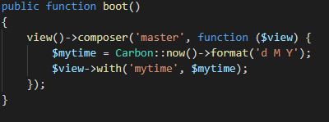  
   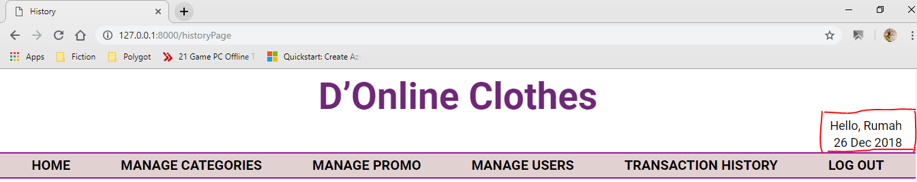
3. Using validator extend named **not_contains** for alpha_dash (which is validating for alphabets, numbers, dash and underscore) for the purpose of rejecting numbers and underscore in validation.  
     
   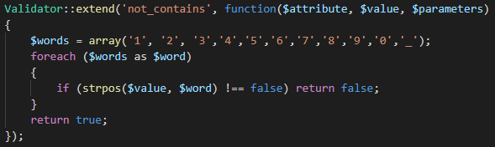  
   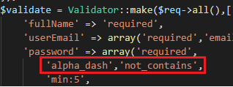
4. Validating whether users exist in databases or not, if not then buyer is changed into ‘Deleted user’ to prevent errors.  
     
   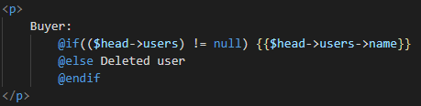

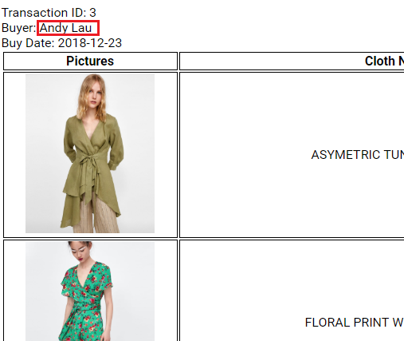  
Before user is deleted  
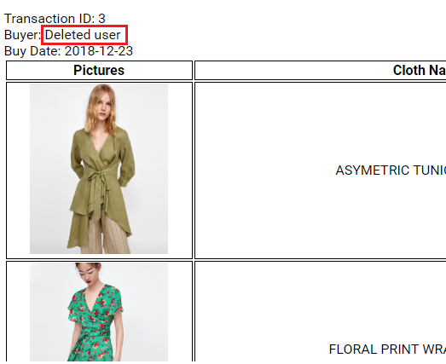  
After user is deleted

1. Using number_format to format currency.  
     
     
   
2. Using 3 middleware for each role (guest, member, and admin) for easier routing setting.  
     
   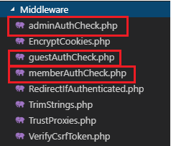  
   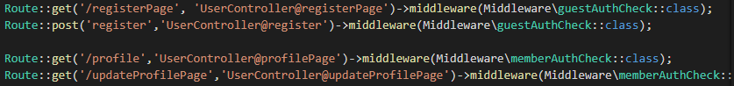  
   
3. Adding option to add avatar (profile picture) for user. Avatar is not necessary for user and thus is optional.  
   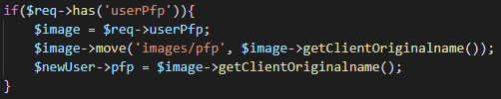
4. Fills all update pages with previous settings automatically. For example this promo page:  
   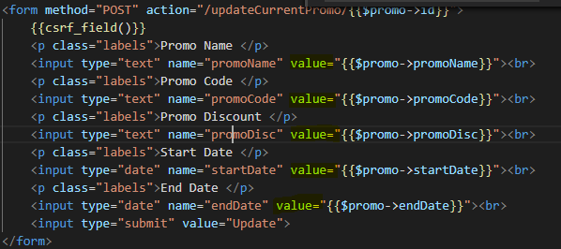  
     
   When admin go to the page:   
   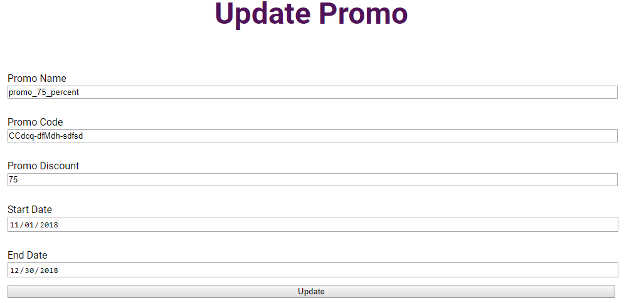

# References

Images

Pfp

* <https://en.wikipedia.org/wiki/File:No_image_available.svg>

clothing

1. cloth.jpg: <https://static.zara.net/photos///2018/I/0/1/p/7689/672/505/2/w/1024/7689672505_2_2_1.jpg?ts=1528387134968>
2. cloth2.jpg: <https://static.zara.net/photos///2018/V/0/1/p/6045/041/400/2/w/1024/6045041400_1_1_1.jpg?ts=1528729067208>
3. cloth3.jpg: <https://static.zara.net/photos///2018/V/0/1/p/3066/217/330/2/w/1024/3066217330_2_5_1.jpg?ts=1527161562236>
4. cloth4.jpg: <https://static.zara.net/photos///2018/I/0/1/p/7540/827/506/2/w/1024/7540827506_2_1_1.jpg?ts=1526665122561>
5. cloth5.jpg: <https://www.zara.com/id/en/oversized-sweatshirt-p08417002.html?v1=5780613&v2=437720>
6. cloth6.jpg: <https://www.zara.com/id/en/embroidered-blouse-with-perforations-p05598044.html?v1=6653609&v2=792586>
7. cloth7.jpg: <https://www.zara.com/id/en/printed-jumpsuit-with-elastic-detail-p02760834.html?v1=6034035&v2=437707>
8. cloth8.jpg: <https://www.zara.com/id/en/printed-jumpsuit-with-tied-belt-p03101216.html?v1=6257551&v2=437707>
9. cloth9.jpg: <https://static.zara.net/photos///2018/V/0/1/p/1701/022/822/2/w/1920/1701022822_9_2_1.jpg?ts=1516624276342>
10. cloth10.jpg: <https://www.zara.com/id/en/floral-print-jumpsuit-p01639060.html?v1=5443002&v2=437707>
11. cloth11.jpg: <https://www.zara.com/id/en/metallic-effect-blouse-p02788788.html?v1=6504598&v2=792586>
12. Stussy Classic Logo Tee <https://www.google.co.id/url?sa=i&source=images&cd=&cad=rja&uact=8&ved=2ahUKEwiczveS6ereAhXTdn0KHSy7BJQQjRx6BAgBEAU&url=https%3A%2F%2Fwww.urbanoutfitters.com%2Fshop%2Fstussy-classic-logo-tee&psig=AOvVaw1yT4JkM26kXfkFfJTLlqPc&ust=1543073031303533>
13. DEUS Venice Hoodie <https://www.google.co.id/url?sa=i&source=images&cd=&cad=rja&uact=8&ved=2ahUKEwjU3ebe6ereAhWWinAKHcJ0A2UQjRx6BAgBEAU&url=https%3A%2F%2Fwww.ebay.co.uk%2Fitm%2FDeus-Ex-Machina-Venice-Address-Crew-Sweatshirt-Navy-%2F323282840721&psig=AOvVaw1vTSN9XVDVKF3YVg6mzUZD&ust=1543073190550353>
14. BAPE Tees <https://www.google.co.id/url?sa=i&source=images&cd=&cad=rja&uact=8&ved=2ahUKEwiek6Ct6ureAhULaI8KHeHDAS8QjRx6BAgBEAU&url=https%3A%2F%2Fus.bape.com%2Fproducts%2F1d30-210-026&psig=AOvVaw2YtaZjp7V1M6bYXEitGHU1&ust=1543073320762412>
15. Trasher KCUF T-Shirt <https://www.google.co.id/url?sa=i&source=images&cd=&cad=rja&uact=8&ved=2ahUKEwiJrbbT6ureAhVNU30KHR6tCZ4QjRx6BAgBEAU&url=https%3A%2F%2Fwww.routeone.co.uk%2Fclothing%2Ft-shirts%2Fgraphic-t-shirts%2Fthrasher-kcuf-t-shirt-light-pink.htm&psig=AOvVaw0hwHPZeRDQwHsyAXBV7UaM&ust=1543073423974093>
16. Trasher Yellow T-Shirt <https://www.google.co.id/url?sa=i&source=images&cd=&cad=rja&uact=8&ved=2ahUKEwjg3Oz36ureAhUCWX0KHdvCBnMQjRx6BAgBEAU&url=https%3A%2F%2Fnewgraphictees.com%2Fproduct%2Fthrasher-yellow-t-shirt-2%2F&psig=AOvVaw0hwHPZeRDQwHsyAXBV7UaM&ust=1543073423974093>
17. Marvel Logo T-Shirt <https://www.google.co.id/url?sa=i&source=images&cd=&cad=rja&uact=8&ved=2ahUKEwiHp82y6-reAhUaT30KHavBBZ4QjRx6BAgBEAU&url=https%3A%2F%2Fyaoota.com%2Fen-eg%2Fproduct%2Fmarvel-t-shirt-price-from-geeqshop-egypt&psig=AOvVaw3dPsSFdH9DRa1GQJsYN7SQ&ust=1543073633856537>
18. Marvel Hulk T-shirt <https://www.google.co.id/url?sa=i&source=images&cd=&cad=rja&uact=8&ved=2ahUKEwjw5IHN6-reAhVGcCsKHYjfDvUQjRx6BAgBEAU&url=https%3A%2F%2Fwww.uniqlo.com%2Fus%2Fen%2Futgp-marvel-short-sleeve-graphic-t-shirt-hulk-412191.html&psig=AOvVaw3dPsSFdH9DRa1GQJsYN7SQ&ust=1543073633856537>
19. Batman Tees <https://www.google.co.id/url?sa=i&source=images&cd=&cad=rja&uact=8&ved=2ahUKEwjJ3dP_6-reAhUENo8KHWDAD5wQjRx6BAgBEAU&url=https%3A%2F%2Fwww.walmart.ca%2Fen%2Fip%2Fbatman-boys-short-sleeve-t-shirt-2t%2F6000196459527&psig=AOvVaw1SzLWFwangPYEsZtdH6qge&ust=1543073798041026>
20. DC Comics Limited Tees <https://www.google.co.id/url?sa=i&source=images&cd=&cad=rja&uact=8&ved=2ahUKEwiCsdDC7OreAhUM6Y8KHelkAsEQjRx6BAgBEAU&url=https%3A%2F%2Fwww.amazon.com%2FComics-Periodic-Table-Super-Heroes%2Fdp%2FB00BPE3HXC&psig=AOvVaw1xjqvwWToM4Gy01UsdKR3h&ust=1543073924487344>
21. The Flash Tees <https://www.google.co.id/url?sa=i&source=images&cd=&cad=rja&uact=8&ved=2ahUKEwiiiNHv7OreAhWLO48KHcCiD5EQjRx6BAgBEAU&url=https%3A%2F%2Foldnavy.gap.com%2Fbrowse%2Fproduct.do%3Fpid%3D120549&psig=AOvVaw1xjqvwWToM4Gy01UsdKR3h&ust=1543073924487344>
22. Disney Raglon Red <https://www.google.co.id/url?sa=i&source=images&cd=&cad=rja&uact=8&ved=2ahUKEwisjpap7ereAhWMdn0KHTLJD1gQjRx6BAgBEAU&url=https%3A%2F%2Fdisneyparks.disney.go.com%2Fblog%2F2016%2F04%2Fnew-shirts-for-disney-fans-coming-to-disney-parks-online-store-in-spring-2016%2F&psig=AOvVaw3rsj8vxrT1UwERSQx8DIsG&ust=1543074116702045>
23. Im Not Crazy Tees <https://www.google.co.id/url?sa=i&source=images&cd=&cad=rja&uact=8&ved=2ahUKEwjHvdjG7ereAhWJrI8KHY05DGMQjRx6BAgBEAU&url=https%3A%2F%2Fwww.etsy.com%2Flisting%2F541300315%2Fim-not-crazy-t-shirt-disney-tees&psig=AOvVaw3rsj8vxrT1UwERSQx8DIsG&ust=1543074116702045>
24. Pologize Business Polo Shirt <https://www.google.co.id/url?sa=i&source=images&cd=&cad=rja&uact=8&ved=2ahUKEwiz_Mr27ereAhWBL48KHTHhAkcQjRx6BAgBEAU&url=https%3A%2F%2Fpologize.com%2Fproducts%2Fpologize%25E2%2584%25A2-business-polo-shirt&psig=AOvVaw0gqSNHIZ8v8owWUwSRrGTZ&ust=1543074311270184>
25. Polo Knit Cashmere <https://www.google.co.id/url?sa=i&source=images&cd=&cad=rja&uact=8&ved=2ahUKEwjajbOf7ureAhULuo8KHQC7BuYQjRx6BAgBEAU&url=https%3A%2F%2Fwww.armani.com%2Flt%2Farmanicom%2Fgiorgio-armani%2Fpolo-shirt-in-knit-cashmere-and-silk_cod46589216cg.html&psig=AOvVaw0gqSNHIZ8v8owWUwSRrGTZ&ust=1543074> 311270184
26. ZARA Basics Suits <https://www.google.co.id/url?sa=i&source=images&cd=&cad=rja&uact=8&ved=2ahUKEwiPhurK7ureAhWFdH0KHVBZAPgQjRx6BAgBEAU&url=https%3A%2F%2Fwww.zara.com%2Fus%2Fen%2Fman-suits-basics-l811.html&psig=AOvVaw3E9SS8ZXPaViFgfYTkqWi8&ust=1543074490140558>
27. ZARA Check Suit Blazer <https://www.google.co.id/url?sa=i&source=images&cd=&cad=rja&uact=8&ved=2ahUKEwjq14nu7ureAhUDtI8KHT-TDPMQjRx6BAgBEAU&url=https%3A%2F%2Fwww.zara.com%2Fhu%2Fen%2Fcheck-suit-blazer-p00706443.html%3Fv1%3D6492569%26v2%3D1079301&psig=AOvVaw3E9SS8ZXPaViFgfYTkqWi8&ust=1543074490140558>
28. ZARA Black Jacket <https://www.google.co.id/url?sa=i&source=images&cd=&cad=rja&uact=8&ved=2ahUKEwjUld6a7-reAhWHQo8KHUq5CbUQjRx6BAgBEAU&url=http%3A%2F%2Fwww.saifikitchen.com%2Fproduct%2Fzara-men-black-jacket%2F&psig=AOvVaw3E9SS8ZXPaViFgfYTkqWi8&ust=1543074490140558>
29. Giordano Linen Sleeve Man <https://www.google.co.id/url?sa=i&source=images&cd=&cad=rja&uact=8&ved=2ahUKEwjpiLXX7-reAhUNEnIKHaWPBKAQjRx6BAgBEAU&url=https%3A%2F%2Fwww.aliexpress.com%2Fitem%2FGiordano-Men-Shirt-Linen-Short-Sleeve-Pocket-Shirt-Slim-Fit-Solid-Colors-Stripe-Design-2018-New%2F32859855657.html&psig=AOvVaw3Kz94bVhl7CXnVFKDxhla6&ust=1543074776304570>
30. ZARA Tuxedo Woman Trim <https://www.google.co.id/url?sa=i&source=images&cd=&cad=rja&uact=8&ved=2ahUKEwjP-5P37-reAhUVSo8KHYMABlMQjRx6BAgBEAU&url=https%3A%2F%2Fwww.zara.com%2Fus%2Fen%2Ftuxedo-pants-with-side-trim-detail-p02172783.html&psig=AOvVaw3EgfE7tykHEjxbUORWvbeo&ust=1543074853111574>
31. ZARA Woman Blazers <https://www.google.co.id/url?sa=i&source=images&cd=&cad=rja&uact=8&ved=2ahUKEwjGwsGv8OreAhXELI8KHZT_C70QjRx6BAgBEAU&url=https%3A%2F%2Fwww.zara.com%2Fus%2Fen%2Fwoman-blazers-l1055.html&psig=AOvVaw3EgfE7tykHEjxbUORWvbeo&ust=1543074853111574>
32. H&M Denim Bib <https://www.google.co.id/url?sa=i&source=images&cd=&cad=rja&uact=8&ved=2ahUKEwiv_PLR8OreAhULpY8KHc55B9MQjRx6BAgBEAU&url=https%3A%2F%2Fwww.refinery29.com%2Fen-us%2F2017%2F03%2F145866%2Fhm-new-unisex-collection-spring-2017&psig=AOvVaw2fVHSfzWUFWPOPCan--f2V&ust=1543075041440696>
33. KENZO Unisex Tees <https://www.google.co.id/url?sa=i&source=images&cd=&cad=rja&uact=8&ved=2ahUKEwjh9Yim8ereAhXEv48KHei-CvQQjRx6BAgBEAU&url=https%3A%2F%2Fwww.shopstyle.com%2Fbrowse%2Ftees-and-tshirts%2Fkenzo&psig=AOvVaw3FK4QJi0Gfv4WPjJdyAedi&ust=1543075216295877>
34. KENZO Tiger Shirt <https://www.google.co.id/url?sa=i&source=images&cd=&cad=rja&uact=8&ved=2ahUKEwj65sDQ8ereAhUKLo8KHduNCJMQjRx6BAgBEAU&url=https%3A%2F%2Fwww.shopbop.com%2Ftiger-shirt-kenzo%2Fvp%2Fv%3D1%2F1592406430.htm&psig=AOvVaw3FK4QJi0Gfv4WPjJdyAedi&ust=1543075216295877>
35. KENZO Winter Mode <https://www.google.co.id/url?sa=i&source=images&cd=&cad=rja&uact=8&ved=2ahUKEwjgpYjv8ereAhWMrI8KHYm9BC4QjRx6BAgBEAU&url=https%3A%2F%2Fjuice.com.sg%2Fkenzo-goes-beast-mode-winter%2F&psig=AOvVaw3FK4QJi0Gfv4WPjJdyAedi&ust=1543075216295877>

Malls

* Baywalk.jpg: <https://c1.staticflickr.com/4/3798/11285302016_bd448d6a69_b.jpg>
* Baywalk2.jpg: <https://jakartayuk.files.wordpress.com/2014/12/85309.jpg>
* Central_park.jpg: <http://jakarta.panduanwisata.id/files/2013/02/central-park1.jpg>
* Central_park2.jpg: <https://s3-ap-southeast-1.amazonaws.com/centralparkjakarta.com/wp-content/uploads/2017/10/17152306/tribeca1.jpg>
* Central_park3.jpg: <https://s3-ap-southeast-1.amazonaws.com/centralparkjakarta.com/wp-content/uploads/2017/10/17151704/NEO-SOHO-JAKARTA3.jpg>
* Central_park4.jpg: <https://res.cloudinary.com/fleetnation/image/private/c_fit,w_1120/g_south,l_text:style_gothic2:%C2%A9%20Mukti%20Ariawan,o_20,y_10/g_center,l_watermark4,o_25,y_50/v1484398499/cuuh9gqz5yi5pmlgusck.jpg>
* Grand_indonesia.jpg: <https://www.grand-indonesia.com/wp-content/uploads/2016/02/Foto3.jpg>
* Grand_indonesia2.jpg: <http://static.asiawebdirect.com/m/bangkok/portals/indonesia-holidays-com/homepage/jakarta/shopping/grand-indonesia-shopping-town/pagePropertiesImage/grand-indonesia-shopping-town.jpg>
* Grand_indonesia3.jpg: <https://a.travel-assets.com/findyours-php/viewfinder/images/res60/210000/210129-Jakarta.jpg>
* Kasablanka.jpg: <https://www.kotakasablanka.co.id/media/images/img_kokas_1398372896_1520319436.jpg>
* Kasablanka2.jpg: <https://t-ec.bstatic.com/images/hotel/max1024x768/125/125257893.jpg>
* Kasablanka3.jpg: <https://i.ytimg.com/vi/icAJ9KJZt5Q/maxresdefault.jpg>
* Kasablanka4.jpg: <https://jakartayuk.files.wordpress.com/2014/12/20141215_123328.jpg>
* Kasablanka5.jpg: <http://4.bp.blogspot.com/-zLJfDccKMHQ/VlKPjqHmLmI/AAAAAAAAAzQ/lkmAzvyuLHU/s1600/20151122_174040.jpg>
* Plaza_indonesia.jpg: <http://www.plazaindonesia.com/res/images/store-na-img.jpg>
* Plaza_indonesia1.jpg: <http://sp.beritasatu.com/media/images/original/20150224131910496.jpg>
* Plaza_indonesia2.jpg: <https://www.gettyimages.com/detail/photo/interior-of-the-plaza-indonesia-shopping-high-res-stock-photography/521763012?esource=SEO_GIS_CDN_Redirect>
* Plaza_indonesia3.jpg: <https://en.wikipedia.org/wiki/Plaza_Indonesia#/media/File:Mall_culture_jakarta03.jpg>

Logo

* Email.png: <http://www.iconarchive.com/show/100-flat-icons-by-graphicloads/email-2-icon.html>
* Facebook.png: <http://www.iconarchive.com/show/social-bookmark-icons-by-yootheme/social-facebook-box-blue-icon.html>
* Instagram.png: <http://www.iconarchive.com/show/free-instagram-icons-by-designbolts/Active-Instagram-3-icon.html>
* Line.png: <https://upload.wikimedia.org/wikipedia/commons/thumb/4/41/LINE_logo.svg/2000px-LINE_logo.svg.png>
* Telephone.png: <http://www.iconarchive.com/show/100-flat-icons-by-graphicloads/phone-call-icon.html>
* Twitter.png: <https://logos-download.com/wp-content/uploads/2016/02/Twitter_logo_bird_transparent_png.png>

partners

* Uniqlo.jpg: <https://faneuilhallmarketplace.com/wp-content/uploads/sites/203/2017/05/uniqlo-logo.jpg>
* Uniqlo1.jpg: <http://cdn2.tstatic.net/jogja/foto/bank/images/gerai-uniqlo_20180210_221202.jpg>
* Uniqlo2.jpg: <https://uniqlo.scene7.com/is/image/UNIQLO/eu-pc-071117-stores-detail-fr-printemps-nation?$jpg$>
* Uniqlo3.jpg: <https://uniqlo.scene7.com/is/image/UNIQLO/eu-pc-251017-stores-detail-uk-oxford?$jpg$>
* zara.png: <https://upload.wikimedia.org/wikipedia/commons/thumb/f/fd/Zara_Logo.svg/2000px-Zara_Logo.svg.png>
* zara1.jpg: <http://im.rediff.com/getahead/2017/may/04zara-mumbai10.jpg>
* zara2.jpg: <http://www.miami.com/wp-content/uploads/sites/2/2017/12/Zara1-e1513267831454-1200x707.jpg>
* zara3.jpg: <https://www.irishtimes.com/polopoly_fs/1.3302774.1511449005!/image/image.jpg_gen/derivatives/box_620_330/image.jpg>